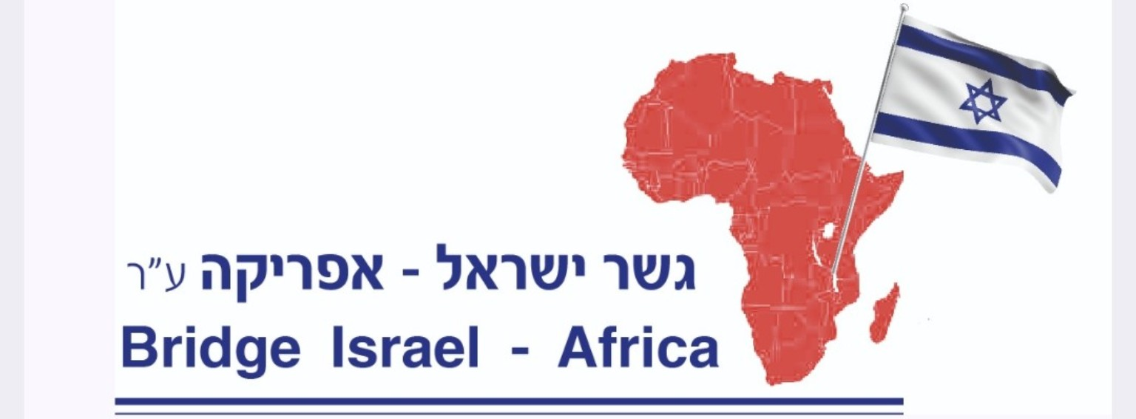
REPORT ON GRAIN DISTRIBUTION
TO ETHIOPIAN JEWS STILL WAITING FOR ALIYAH
A Humanitarian Initiative of Compassion, Solidarity, and Hope

1. Introduction
For more than 30 years, members of the Ethiopian Jewish community have continued to face hardship and uncertainty while waiting for the opportunity to make Aliyah—their long-awaited journey to the Land of Israel.
Many families continue to struggle with poverty, food insecurity, and difficult living conditions. Their prolonged wait has placed a heavy burden on parents, children, and elderly people who hold firmly to their hope of reuniting with their people and building a future in Israel.
From October 18 to November 2, a humanitarian grain distribution initiative was carried out to visit and support Ethiopian Jewish families still suffering in Ethiopia while waiting for Aliyah. This effort was an expression of love, compassion, and solidarity with a community whose hopes and struggles must not be forgotten.

2. Purpose of the Grain Distribution
The primary purpose of this initiative was to provide immediate food assistance to Ethiopian Jewish families experiencing economic hardship while continuing to wait for Aliyah.
The objectives were to:
- Provide essential grains to families facing food insecurity.
- Visit families and witness their living conditions firsthand.
- Reduce the daily burden of obtaining basic food supplies.
- Bring encouragement, dignity, and hope to families enduring a prolonged wait.
- Demonstrate practical solidarity with the Ethiopian Jewish community.
- Thank the friends and supporters of Israel whose generosity made this humanitarian effort possible.

3. Distribution Period and Implementation
Distribution dates: October 18 – November 2
During this period, our team visited Ethiopian Jewish families in Ethiopia who continue to experience hardship while waiting for Aliyah. Grain was distributed to provide essential food assistance and bring encouragement to those facing difficult circumstances.
These visits allowed us to meet families personally, hear their concerns, and witness the challenges they continue to face after decades of waiting.
Beyond the food itself, this initiative carried an important message:
You have not been forgotten. Your suffering matters, your dignity matters, and your hope for the future matters.
The distribution represented more than material assistance. It was a practical demonstration of friendship, compassion, and commitment to stand alongside these families during a difficult period in their lives.

4. The Continuing Struggle of Ethiopian Jews Awaiting Aliyah
For many Ethiopian Jewish families, the dream of Aliyah has been accompanied by years of waiting, uncertainty, and sacrifice. Families continue to hope for the opportunity to immigrate to Israel, reunite with relatives, and establish a secure future.
The prolonged waiting period makes humanitarian support especially important. Food assistance can help meet immediate needs, but the community also requires continued attention, advocacy, and practical support.
Our responsibility is not only to remember these families in our words and prayers, but also to respond to their needs through meaningful action.

5. Appreciation to Our Supporters
We extend our sincere gratitude to all the friends of Israel, donors, volunteers, and partners who contributed to this grain distribution initiative.
Your generosity helped bring practical assistance to families facing difficult circumstances. Every contribution represented an act of kindness and a message of hope to those who continue to wait.
We recognize that behind every donation is a heart willing to care for others. May your generosity encourage further acts of compassion and inspire more people to stand with the Ethiopian Jewish community.

6. A Biblical Message of Compassion
The Bible reminds us of the importance of caring for those who are hungry and vulnerable.
Proverbs 19:17 (KJV)
“He that hath pity upon the poor lendeth unto the LORD; and that which he hath given will he pay him again.”
Isaiah 58:10 (KJV)
“And if thou draw out thy soul to the hungry, and satisfy the afflicted soul; then shall thy light rise in obscurity, and thy darkness be as the noonday.”
These Scriptures remind us that genuine compassion must be expressed through action. Providing food to families in need is one way to demonstrate love, mercy, and faithfulness.

7. Looking Ahead
Although this grain distribution provided important assistance, the needs of the Ethiopian Jewish community remain. Continued humanitarian support is necessary to help families facing food insecurity while they await Aliyah.
We encourage friends of Israel, charitable organizations, churches, and individuals of goodwill to continue supporting humanitarian assistance, raising awareness, and advocating for appropriate solutions for Ethiopian Jews waiting for Aliyah.
Our hope is that the day will come when these families can leave behind years of uncertainty, reunite with loved ones, and begin a new chapter of life in Israel.

8. Conclusion
The grain distribution conducted from October 18 to November 2 was a meaningful expression of compassion toward Ethiopian Jewish families who have endured decades of hardship while waiting for Aliyah.
By visiting these families and providing essential food assistance, we sought to bring relief, encouragement, and renewed hope. While grain can help meet today's needs, our commitment must continue until these families receive the support and attention they deserve.
We stand with Ethiopian Jews waiting for Aliyah. We remember their struggles, honor their dignity, and continue to hope for a better future.
May the Lord bless every supporter, strengthen every family, and bring comfort and hope to all those who continue to wait.

With gratitude and commitment,
Bridge Israel–Africa / Friends of Israel Humanitarian Initiative

Photo Documentation of the Grain Distribution
Photographs documenting the grain distribution and visits to Ethiopian Jewish families awaiting Aliyah, October 18 – November 2.
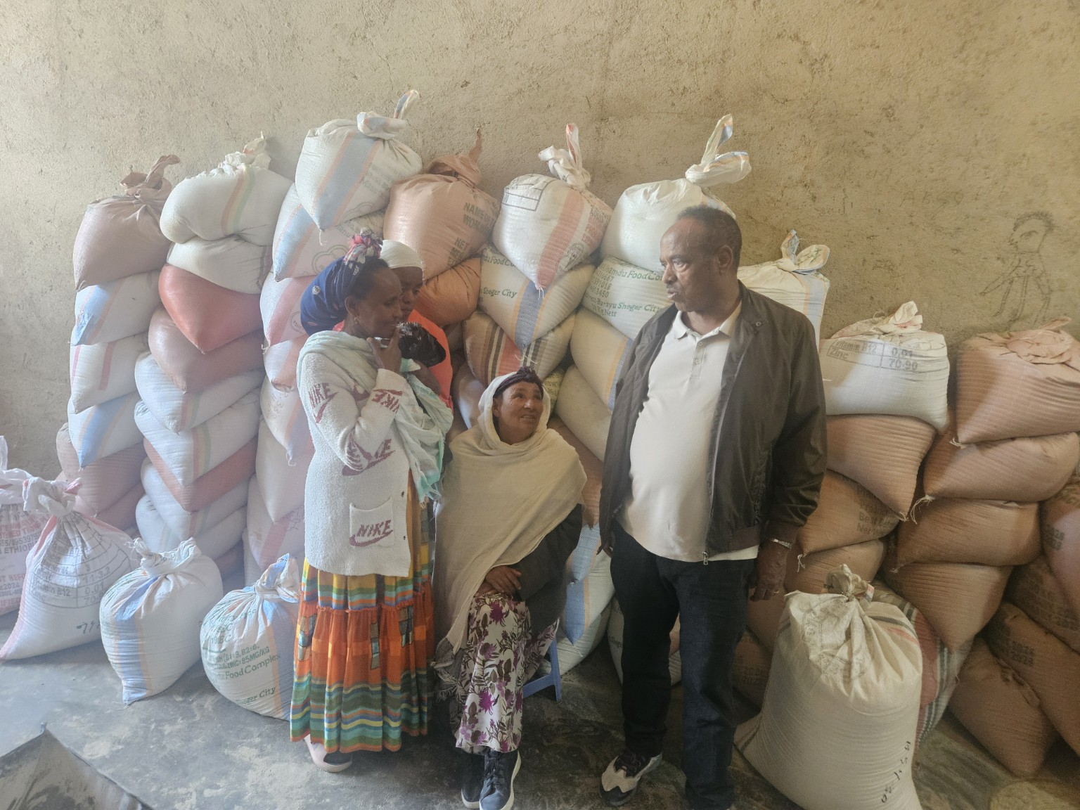
Photo 1: Grain distribution activities and humanitarian visits.

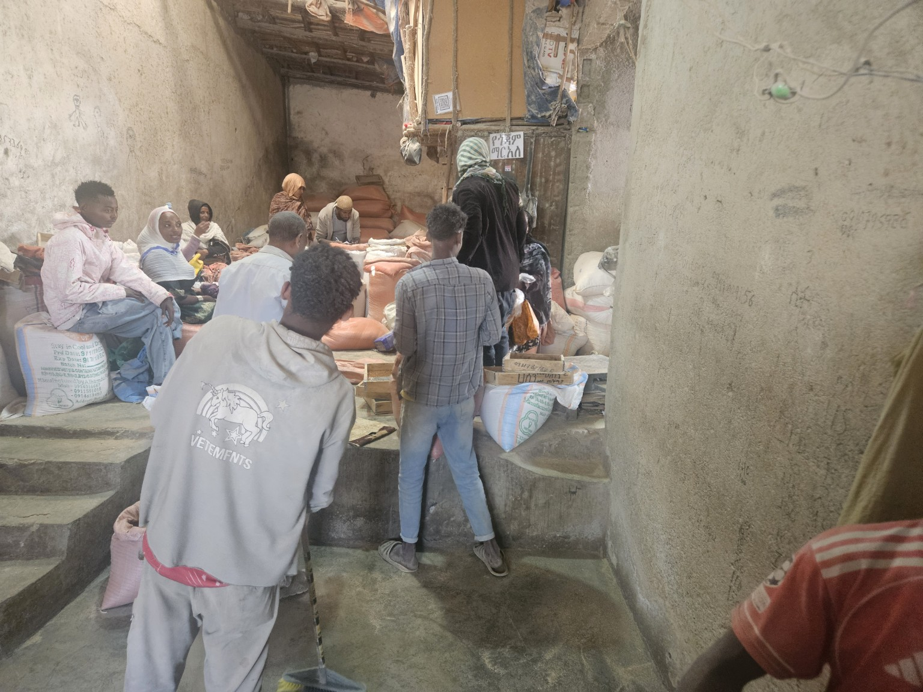
Photo 2: Grain distribution activities and humanitarian visits.

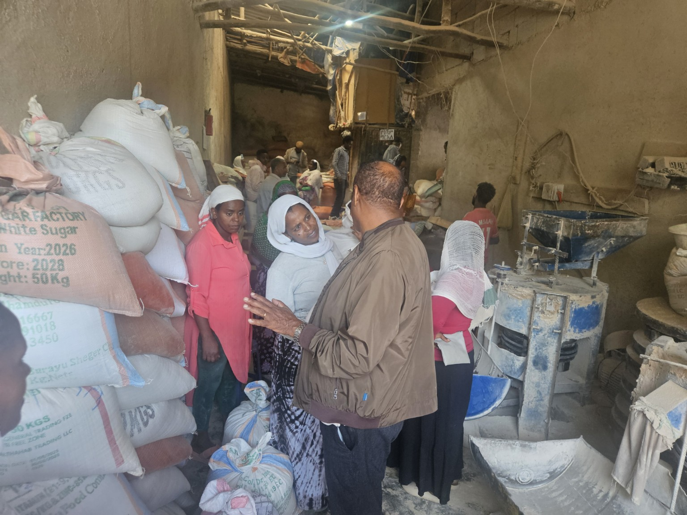
Photo 3: Grain distribution activities and humanitarian visits.

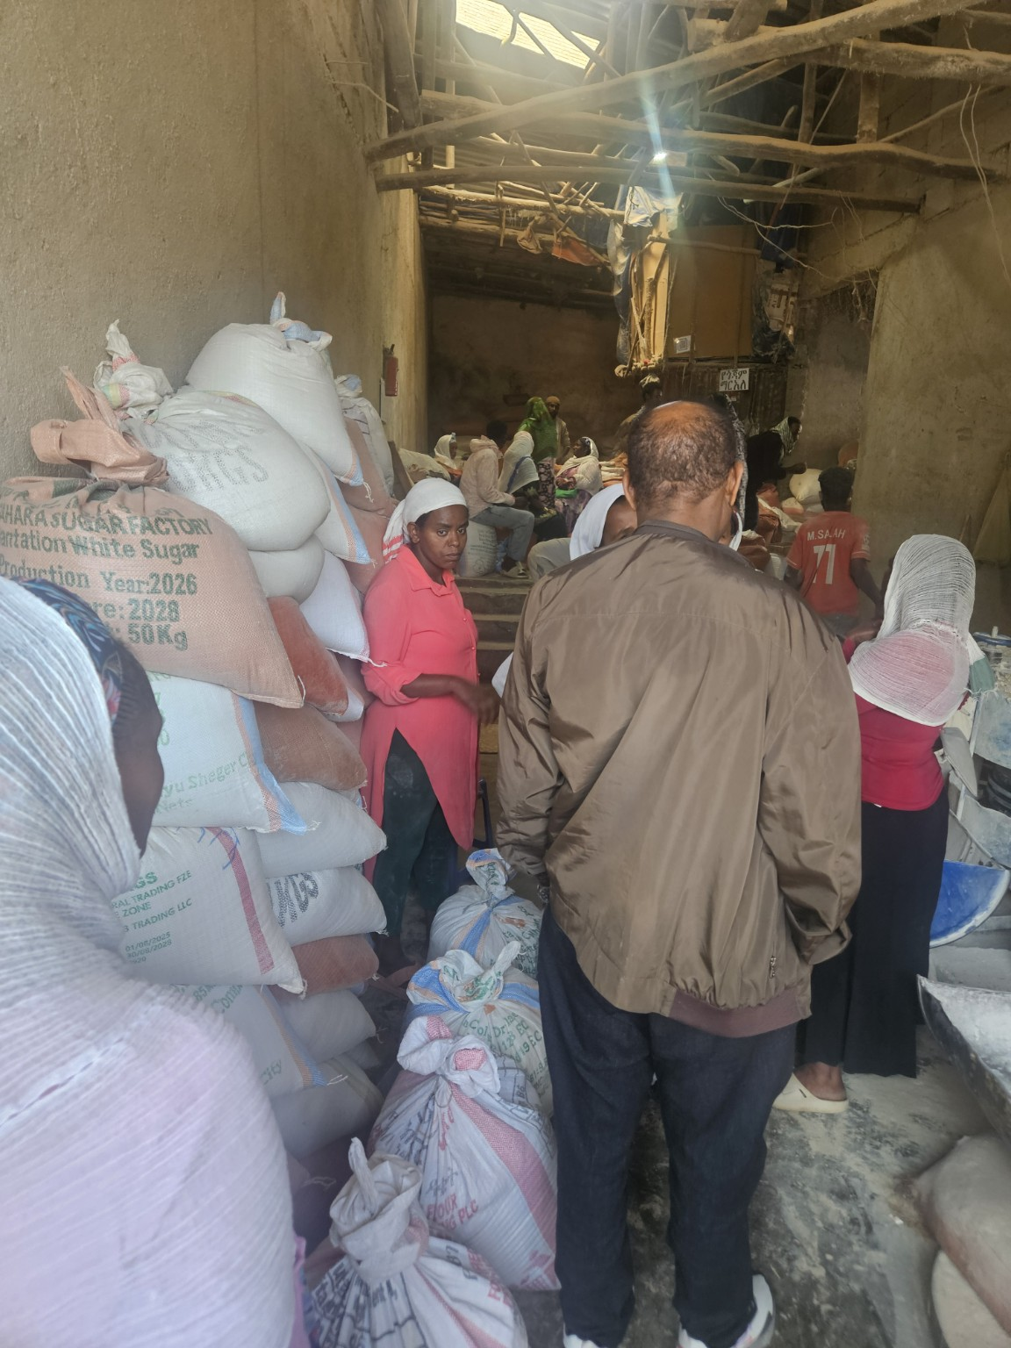
Photo 4: Grain distribution activities and humanitarian visits.

